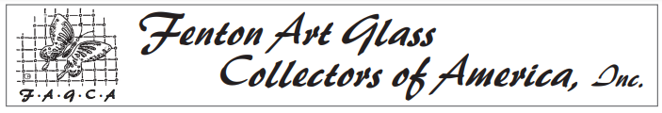
2023 BOARD NOMINATION FORM

Name of Nominee __________________________________________________________________________________

Membership # _____________________________________________________________________________________

Address of Nominee ________________________________________________________________________________

Phone number_________________________ Email _______________________________________________________

Name of Nominator (if not the same as nominee) _________________________________________________________

Please check the appropriate box and answer the following questions:
I am nominating myself. I am nominating another.
PLEASE NOTE: If you are nominating someone other than yourself, please check with that person to make sure they are willing to serve!

Feel free to continue your answers on a separate sheet if needed.

- What positive contributions do you feel the nominee would bring to the FAGCA Board and, through the Board, to FAGCA and its members?
__________________________________________________________________________________________

__________________________________________________________________________________________

__________________________________________________________________________________________

__________________________________________________________________________________________

__________________________________________________________________________________________

__________________________________________________________________________________________

__________________________________________________________________________________________

__________________________________________________________________________________________

__________________________________________________________________________________________

__________________________________________________________________________________________

[Continue on back]
- How long has the nominee been a member of FAGCA?

less than 3 yrs 3 to 5 years longer than 5 years

- What past contributions has this member made to FAGCA and/or to a local club chapter?

___________________________________________________________________________________________

___________________________________________________________________________________________

___________________________________________________________________________________________

___________________________________________________________________________________________

___________________________________________________________________________________________

___________________________________________________________________________________________

___________________________________________________________________________________________

___________________________________________________________________________________________

___________________________________________________________________________________________

- Please list other glass clubs to which the nominee belongs. ___________________________________________

___________________________________________________________________________________________

___________________________________________________________________________________________

___________________________________________________________________________________________

___________________________________________________________________________________________

Note: FAGCA Board members do not receive compensation for work, expertise, or travel associated with Board activities. Upon submission of itemized bills and a FAGCA reimbursement form, they may be reimbursed for all or a portion of travel or other expenses incurred as a result of Board service. No Officer, Trustee, and/or member of FAGCA is permitted to borrow or appropriate FAGCA funds for personal use in any manner. Any conviction of so doing will meet with immediate expulsion from FAGCA in the manner set forth in the Bylaws.
Please return completed form by May 15, 2023 to
FAGCA Board Nominations, PO Box 384, Williamstown, WV 26187
Questions? FAGCA office number is (304) 375-6196.

