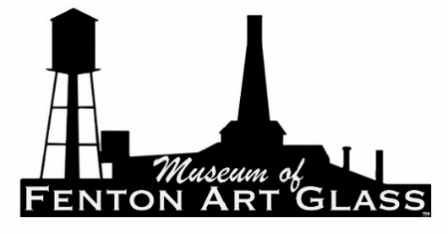
In-Kind Contribution Deed of Gift Form
This form, to be filled in and signed by each donor of museum/library materials, conveys ownership and all property rights to the Museum of Fenton Art Glass. Place this form inside the container holding the donated items and send a copy to the Museum Administrator. Only the copy sent to the Administrator shall be signed by the Administrator and kept on file permanently with the museum. Digital archiving is acceptable. The Administrator shall return a copy of the signed document to the donor for their records.

DEED OF GIFT
I/We, the undersigned, do hereby transfer, give, assign, and set over to the Fenton Art Glass Collectors of America, Inc., a Wisconsin corporation trading as the Museum of Fenton Art Glass (the “Museum”), by way of an unrestricted gift, without consideration, all my/our right, title, and interest in the following described property, in fee simple absolute. I/We warrant that I/we own such property (or are the authorized representative of the owner) and have the right to convey it to the Museum. The Museum may hold, administer, and dispose of the described property as it sees fit, as the sole and unrestricted owner thereof. By signing this form, I/We agree to these terms. Value assigned is for donor records. Donations are tax deductible to the extent the law allows; the Museum is a public charity under Section 501(c)(3) of the Internal Revenue Code.

PROPERTY LIST (continue on another page if needed) Value

1. ______________________________________________________________________$ _________________________

2. ______________________________________________________________________$ _________________________

3. ______________________________________________________________________$ _________________________

4. ______________________________________________________________________$ _________________________

Cash Donation in the amount of $___________________to be used as part of the:
Checks should be made out to the FAGCA / Museum Fund
General Fund ☐ Building Fund ☐ Acquisitions Fund ☐
Split _________________________________________________________________________

Donor Signed: ___________________________________________________________ Date: ______________________

Donor Name/s (print): _______________________________________________________________________________

Address: ______________________________________________________________ Phone: ______________________

City/State/Zip: ______________________________________________________________________________________

Accepted by: ___________________________________________________________ Date: _______________________
(on behalf of the Museum of Fenton Art Glass)

Administrator Signature: __________________________________________________ Date: ______________________

